Catalog

1.Safety instructions and waiver of liability 2

1.1 Safety Instructions 2

1.2 Lianbility Exclusion 2

2.Overview 3

2.1 Features 3

2.2 MPPT technology 4

2.3 MPPT—Four Charging Stage 5

3.Dimension 7

3.1 Structure & Characteristics of MT3075-BT 8

3.2 Option Accessories 8

3.2.1 Bluetooth Communication 9

4.Structure & Characteristics 9

4.1 temperature sensor 9

5. Installation 9

5.1 Installation Notes 9

5.2 Mounting Location Requirements 10

5.3 Wiring Specifications 10

5.4 Connection 11

6. Operation 12

6.1 Status Description 13

6.3 The interface automatically cycles 13

6.4 Key function 15

7. Parameters setting 15

7.1 Low voltage protection 16

7.2 Low Voltage reconnect 17

7.4 Battery type 17

7.5 Load mode 18

7.6 Fault indication 19

7.7 Protection 20

7.8 Maintenance 21

**If you need bluetooth wireless software.see other manual.**

**Contact us if you have any question,Our email is**

**[coolper_us@163.com](mailto:coolper_us@163.com)**

# **1.Safety instructions and waiver of liability**

## **1.1 Safety Instructions**

The following symbols are used throughout this manual to indicate potentially dangerous conditions or mark important safety instructions.Please take care when meeting these symbols.



WARNING:Indicates a potentially dangerous condition.Use extreme caution when performing this task.



CAUTION:Indicates a critical procedure for safe and proper operation of the controller.

CAUTION:

1. There are no user serviceable parts inside the controller.Do not disassemble or attempt to repair the controller.
2. Keep children away from batteries and the charge controller.

## **1.2 Lianbility Exclusion**

The manufacturer shall not be liable for damages,especially on the battery,caused by use other than as intended or as mentioned in this manual or if the recommendations of the battery manufacturer are neglected.The manufacturer shall not be liable if there has been service or repair carried out by any unauthorized person,unusual use,wrong installation,or bad system design.

## 

**2.Overview**

## **2.1 Features**

Magic series solar controller is based on an advanced maximum power point tracking (MPPT) technology developed, dedicated to the solar system, the controller conversion efficiency up to 98%.

It comes with a number of outstanding features, such as:

1. Innovative Max Power Point Tracking(MPPT) technology, tracking efficiency >99.9%

2. Full digital technology, high charge conversion efficiency up to 98%

3. LCD display design, read operating data and working condition easily.

4. Real-time energy statistics function.

5. 12/24V automatic recognition

6. Liquid,Gel,AGM and Lithium battery for selection

7. External temperature sensor, automatic temperature compensation

8. Built-in temperature sensor, when the temperature exceeds the set value, the charging current will lower down followed by the decrease of temperature, so as to control the controller’s temperature rise

9. Four stages charge way: MPPT, boost, equalization, float With current-limiting charging mode, when the power of solar panel is over-sized and charging current exceeds the rated current, the controller will lower the charging power, which enables the system to work under the rated charging current

10. Multiple load control modes: Always on, Dusk to Dawn, Evening, Manual

11. Support Android mobile phone APP,realize wireless monitoring function of solar controller.

12.Use high performance,ultra-low power consumption Bluetooth dedicated chip.Adopt Bluetooth 4.2 and BLE technology,communication distance up to 10m.

13.Real-time automatic fault alarm.

14.Charging and discharging quantities can be counted and displayed by item grouping and month.

15. Perfect EMC & thermal design

16. Full automatic electronic protect function

## **2.2 MPPT technology**

**MPPT profile**

The full name of the MPPT is maximum power point tracking. It is an advanced charging way which could detect the real-time power of the solar Modulel and the maximum point of the I-V curve that make the highest battery charging efficiency.

**Current Boost**

Under most conditions, MPPT technology will "boost" the solar charge current.

MPPT Charging：Power Into the controller (Pmax)=Power out of the controller (Pout)

Iin x Vmp= Iout x Vout

* Assuming 100% efficiency. Actually, the losses in wiring and conversion exist.

Another benefit of MPPT technology is the ability to charge batteries with solar arrays of higher nominal voltages. For example, a 12 Volt battery bank may be charged with a 12-, 24-, nominal off-grid solar array. Grid-tie solar modules may also be used as long as the solar array open circuit voltage (Voc) rating will not exceed the maximum input voltage rating at worst-case (coldest) module temperature. The solar module documentation should provide Voc vs. temperature data.

Higher solar input voltage results in lower solar input current for a given input power. High voltage solar input strings allow for smaller gauge solar wiring. This is especially helpful and economical for systems with long wiring runs between the controller and the solar array.

If the solar module's maximum power voltage (Vmp) is greater than the battery voltage, it follows that the battery current must be proportionally greater than the solar input current so that input and output power are balanced. The greater the difference between the Vmp and battery voltage, the greater the current boost. Current boost can be substantial in systems where the solar array is of a higher nominal voltage than the battery as described in the next section.

**An Advantage Over Traditional Controllers**

Traditional controllers connect the solar module directly to the battery when recharging. This requires that the solar module operate in a voltage range that is usually below the module's Vmp. In a 12 Volt system for example, the battery voltage may range from 10.8-15 Vdc，but the module's Vmp is typically around 16 or 17V.

Because traditional controllers do not always operate at the Vmp of the solar array, energy is wasted that could otherwise be used to charge the battery and power system loads. The greater

**Nominal 12 Volt Solar Module I-V curve and output power graph.**

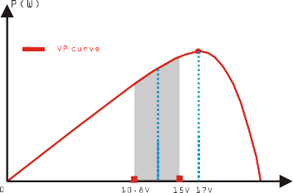

Contrast with the traditional PWM controller,MPPT controller could play a maximum power of the solar panel so that a larger charging current could be supplied. Generally speaking, the MPPT controller's energy utilization efficiency is 15%~20% higher than PWM controller. 1.3 The dimensions of MT3075

**Conditions That Limit the Effectiveness of MPPT**

The Vmp of a solar module decreases as the temperature of the module increases. In very hot weather, the Vmp may be close or even less than battery voltage. In this situation, there will be very little or no MPPT gain compared to traditional controllers. However, systems with modules of higher nominal voltage than the battery bank will always have an array Vmp greater than battery voltage. Additionally, the savings in wiring due to reduced solar current make MPPT

**2.3 MPPT—Four Charging Stage**

Magic series controller has a 4-stage battery charging algorithm for rapid, efficient, and safe battery charging.



**MPPT Charge**

In this stage, the battery voltage has not yet reached boost voltage and 100% of available solar power is used to recharge the battery.

**Boost Charge**

When the battery has recharged to the Boost voltage setpoint, constant-voltage regulation is used to prevent heating and excessive battery gassing. The Boost stage remains 120 minutes and then goes to Float Charge. Every time when the controller is powered on, if it detects neither over discharged nor overvoltage, the charging will enter into boost charging stage.

**Float Charge**

After the Boost voltage stage, the controller will reduce the battery voltage to Float voltage setpoint. When the battery is fully recharged, there will be no more chemical reactions and all the charge current transmits into heat and gas at this time. Then the controller reduces the voltage to the floating stage, charging with a smaller voltage and current. It will reduce the temperature of battery and prevent the gassing, also charging the battery slightly at the same time. The purpose of Float stage is to offset the power consumption caused by self consumption and small loads in the whole system, while maintaining full battery storage capacity.

In Float stage, loads can continue to draw power from the battery. In the event that the system load(s) exceed the solar charge current, the controller will no longer be able to maintain the battery at the Float setpoint. Should the battery voltage remains below the boost reconnect charging voltage, the controller will exit Float stage and return to Bulk charging.

**Equalize Charge**

Certain types of batteries benefit from periodic equalizing charge, which can stir the electrolyte, balance battery voltage and complete chemical reaction. Equalizing charge increases the battery voltage, higher than the standard complement voltage, which gasifies the battery electrolyte. If it detects that the battery is being over discharged, the solar controller will automatically turn the battery to equalization charging stage, and the equalization charging will be 120mins. Equalizing charge and boost charge are not carried out constantly in a full charge process to avoid too much gas precipitation or overheating of battery.

**WARNING: Risk of explosion!**

Equalizing flooded battery can produce explosive gases, so well ventilation of battery box is necessary.

**3.Dimension**

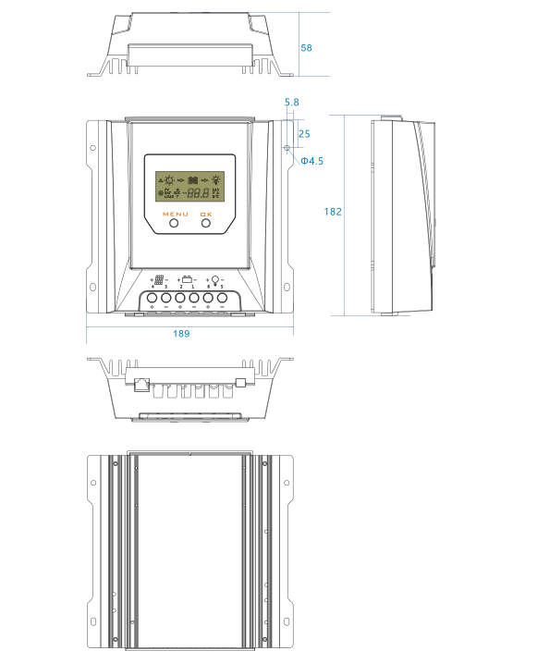

## **3.1 Structure & Characteristics of MT3075-BT**

1. Heat Sink

--dissipate controller heat

1. Plastic Case

--Internal protection

1. LCD

--Display settings and operating status,system parameters

1. Key:MENU、OK

--Set and view the operating parameters

1. RJ11 interface

--Connecting monitoring devices

1. Temperature Sensor Port

--Collect temperature information,Temperature compensation.

1. Load Terminals

--Connected load.

1. Battery Terminals

--Connect the battery

1. Solar module terminals

--Connected solar modules.

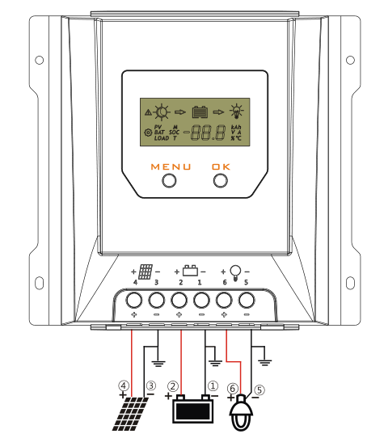

**3.2 Option Accessories**

3.2.1 Bluetooth Communication

Bluetooth communication has the following characteristics:

1.Support Android mobile phone APP

2.Realize wireless monitoring function of solar controller

3.Use high performance,ultra-low power consumption Bluetooth dedicated chip.

4.Adopt Bluetooth 4.2 and BLE technology.

5.communication distance up to 10m

1) This icon in this specification indicates that this BT series solar controller has Bluetooth communication function.

2) Refer to Bluetooth APP instructions for detailed operation of mobile APP .

**4.Structure & Characteristics**

**4.1 temperature sensor**

To collect battery temperature data for temperature compensation so the controller can charge the battery. The temperature sensor connected via interface 6.

If the external temperature sensor is not connected or damaged, the default environment temperature of the controller is 25℃, and the temperature compensation is not carried out when charging.

1. **Installation**

It is recommended to remove the acrylic protective film covering the LCD screen before installation.

**5.1 Installation Notes**

|  |  |
| --- | --- |
| 1 | Connection order: 1)battery 2)panels 3)Load(ensure panels can't get any sunlight when install).The disassembly sequence is contrary to the wiring order . Before wiring installation and adjustment of controller,Always disconnect the solar modules and insurance or circuit breaker of battery terminal. |
| 2 | Connect the inverter (DC / AC) to the battery. Do not connect to the solar controller. |
| 3 | the load system voltage should be the same as solar system.it means if your solar system is 12V,your load's system voltage must be the 12V. |
| 4 | When installing for the first time, please make sure the battery voltage more than 8V so that the Charger controller can recognize system.See recognize range. |
| 5 | Make sure the total input voltage under 55V for 12V and 24V and input power is under 390W for 12V system and 780W for 24V system.we suggest the input power more than the half of maximum value. |
| 6 | Don't let controller work for long periods with limit maximum Input power or limit max Solar Input voltage or limit max charge current.The max value could find in label of panels. |
| 7 | The controller will stop output when the battery under 10.7V(adjustable). |
| 8 | The solar charge controller may only be used in PV systems in accordance with this user manual and the specifications of other modules manufacturers.Mo energy source other than a solar generator may be connected to the solar charge controller. |
| 9 | Tighten the wire to ports, otherwise it will produce sparks easily resulting in high temperatures.then burn easily ports.The controller is kept in a cool and breathable place. |
| 10 | Batteries store a large amount of energy , never short circuit a battery under all circumstances.We strongly recommend connecting a fuse directly to the battery to protect any short circuit at the battery wiring. |
| 11 | Install the Charger controller to the battery as close as possible to avoid voltage and power dropping caused by overlong wire and affect normal voltage judgment. |
| 12 | Batteries can produce flammable gases.Avoid making sparks,using fire or any naked flame.Make sure that the battery room is ventilated. |
| 13 | Uses insulated tools and avoid placing metal objects near the batteries. |
| 14 | Avoid touching or short circuiting wires or terminals.Be aware that the voltages on spedcial terminals or wires can be as much as twice the battery voltage.Use isolated tools,stand on dry ground, and keep your hands dry. |
| 15 | Dust and weather will affect MPP(MAX Power Point) tracking.make it clean.Sometimes.The data beat because of it tracking the MAX Power Point. |
| 16 | Be very careful when working with batteries.Wear eye protection.Have fresh water available to wash and clean any contact with battery acid. |
| 17 | Prevent water from entering the internal controller,outdoor installation should avoid direct sunlight and rain penetration. |
| 18 | The LCD display has an error of 0.2 V- 0.3 V, but this is normal |
| 19 | Do not open the heat sink of the solar controller without permission. |

**5.2 Mounting Location Requirements**

Do not mount the solar charge controller outdoors or in wet rooms. Do not subject the solar charge controller to direct sunshine or other sources of heat. Protect the solar charge controller from dirt and moisture. Mount upright on the wall on a non-flammable substrate. Maintain a minimum clearance of 15cm below and around the device to ensure unhindered air circulation. Mount the solar charge controller as close as possible to the batteries.

Mark the position of the solar charge controller fastening holes on the wall, drill 4 holes and insert dowels, fasten the solar charge controller to the wall with the cable openings facing downwards.

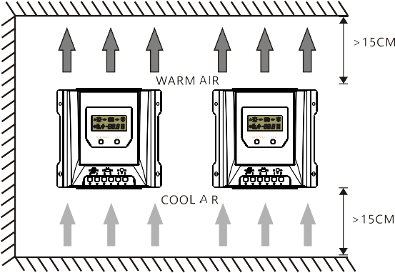

**5.3 Wiring Specifications**

Wiring and installation methods must comply with national and local electrical specifications.

The wiring specifications of the solar, battery and loads must be selected according to rated currents, and see the following table for wiring specifications:

|  |  |  |  |  |  |
| --- | --- | --- | --- | --- | --- |
| Model | Rated charging current | Rated discharging  current | Solar wire  diameter  (AWG) | Battery wire  diameter  (AWG) | Load wire  diameter  (AWG) |
| MT3075-BT | 30A | 30A | #4 | #4 | #4 |

The wire size is only for reference. If there is a long distance between the PV array and the controller or between the controller and the battery, larger wires can be used to reduce the voltage drop and improve performance.

**5.4 Connection**

We strongly recommend connecting a fuse directly to the battery to protect any short circuit at the battery wiring. Solar PV modules create current whenever light strikes them. The current created varies with the light intensity, but even in the case of low levels of light, full voltage is given by the modules. So, protect the solar modules from incident light during installation. Never touch uninsulated cable ends, use only insulated tools, and make sure that the wire diameter is in accordance with the expected currents of solar charge controller. Connections must always be made in the sequence described below.

Be aware that the negative terminals of controller are connected together and therefore have the same electrical potential. If any grounding is required, always do this on the negative wires.

****WARNING: Risk of electric shock! Exercise caution when handing solar wiring. The solar PV array can produce open-circuit voltages in excess of 100V when in sunlight.total input power no more than 390W for 12V system and 780W for 24V system,Pay more attention to it.

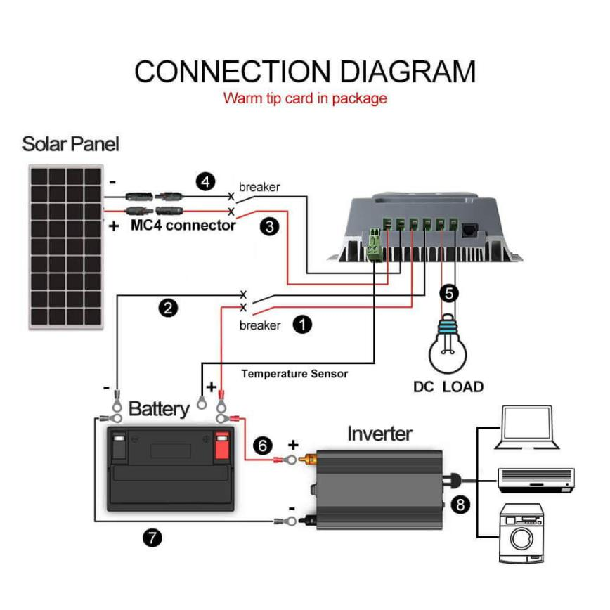

**1st step: Connect the solar module**

Install air circuit breaker between controller and PV modules. Turn off the circuit breaker, and ensure the PV polarity correct, then connect wires between PV modules and controller.

**2nd step:Connect the battery**

Connect the battery connection cable with the correct polarity to the middle pair of terminals on the solar charge controller (with the battery symbol). If the system is 12V, please make sure that the battery voltage is within 10V~15V, else if the system is 24V, the battery voltage should between 20V~30V, the LCD on the controller will begin to show.

**3rd step: Connect the solar module**

Ensure that the solar module is protected from incident light. Ensure that the solar module does not exceed the maximum permissible input current. Connect the solar module connection cable to the correct polarity of the left pair of terminals on the solar charge controller (with the solar module symbol).

**4th step: Connect loads**

Connect the load cable to the correct polarity of the right pair of terminals on the solar charge controller (with the lamp symbol). To avoid any voltage on the wires, please connect the wire to the load before connect to the controller.

**5th step:Confirm connection**

Tighten all cables connected to the controller and remove all the debris around the controller (leaving a space of approx. 5.9 in).

**6th step:Turn on the air circuit breaker**

****Turn on the air circuit breaker between controller and batteries.Turn on the air circuit breaker between controller and PV modules.

**CAUTION: For common-negative system,such as motorhome,it is recommended to use a common-negative controller;but if in the common-negative system,some common-positive equipment are used,and the positive electrode is grounded,the controller may be damaged.**

**6.Operation**

**6.1 Status Description**

|  |  |  |
| --- | --- | --- |
| **Item** | **Icon** | **Status** |
| PV array |  | Daytime, not charging |
|  | Daytime, charging |
|  | Night |
|  | PV voltage、 current and ampere hours |
|  | The total charge ampere hours of the solar panel |
| Battery |  | Battery capacity |
|  | Battery voltage(Programmable Low Voltage Discharge) |
|  | Battery current |
|  | Battery state of charge(in %) |
|  | Temperature(Clear Bluetooth Device Password) |
|  | Battery type(Programmable) |
|  |  | Load voltage(Programmable Low Voltage Reconnect) |
| Load |  | Load current and ampere hours |
|  | The total discharge ampere hours of the load |
|  | Load mode(Programmable) |
|  | The load is on |
|  | The load is off |
| Fault |  | Fault indication. See 7.1.4 |

**PV array charge ampere hours and load ampere hours are off after power failure.**

**6.2 The LCD Display**



**6.3 The interface automatically cycles**

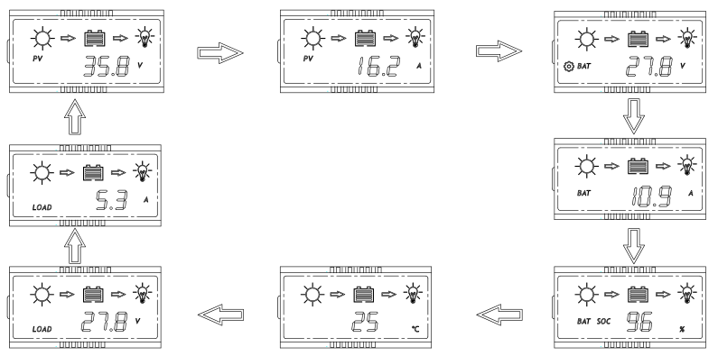

Press OK button to browse the interface

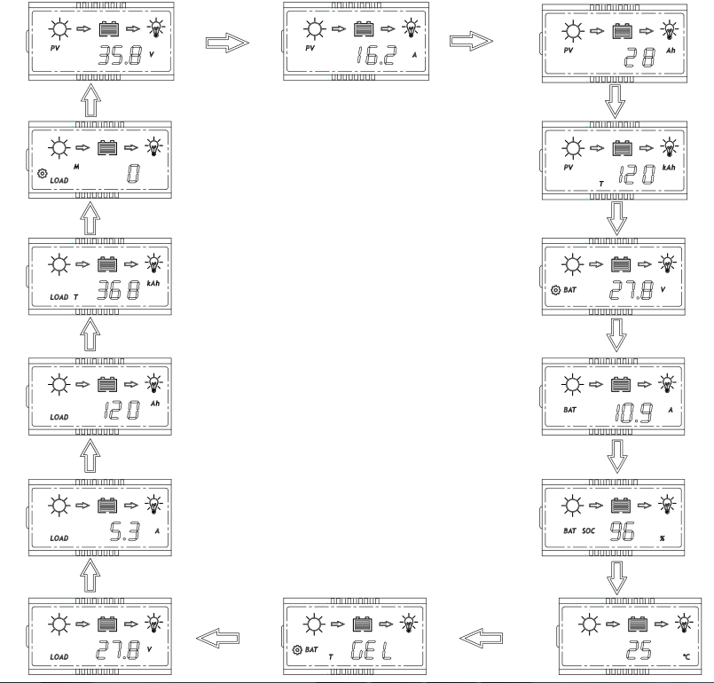

**6.4 Key function**

|  |  |
| --- | --- |
| Mode | Operating |
| Browse interface | Short press OK |
| Static display | Press the MENU and OK key at the same time for 1s, the LCD screen  will lock the interface.  Press the MENU and OK key again for 1s, the LCD interface will unlock  and start scrolling. |
| Setting parameter | Press the MENU key for 1s to enter the setting mode when the icon appears on the display interface, and exit automatically after 30s |
| Load On/Off | When the controller is working in street lamp mode, press the MENU  key for 3s to turn on the load, press the MENU key again or 1min later  the load will be off. |

**7. Parameters setting**

When the display interface appears icon,means that the current parameters can be set,press the MENU key to start setting,then iconflashes,press OK to change the parameter.

**7.1 Low voltage protection**

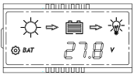When the LCD shows the interface as left ,press the **MENU** Key for 1s,the iconflashes,you can set the controller’s low voltage protection.

1. **Lithium Battery**

When the battery type is lithium battery.the low-voltage protection setting range is 9.0-30.0V(default:9.0V).

**2. Liquid,Gel and AGM Battery**

The low voltage protection of the controller can be divided into two types:battery voltage control and capacity control.

①Battery voltage control

Low voltage protection setting range：

10.8~11.8V/21.6~23.6V/43.2~47.2V(default:11.2/22.4/44.8V).

②Battery capacity control

|  |  |
| --- | --- |
| Display | Low voltage protection |
|  | 11.0~11.6V/22.0~23.2V/44.0-46.4V |
|  | 11.1~11.7V/22.2~23.4V/44.4-46.8V |
|  | 11.2~11.8V/22.4~23.6V/44.8-47.2V |
|  | 11.4~11.9V/22.8~23.8V/45.6-47.6V |
|  | 11.6~12.0V/23.2~24.0V/46.4-48.0V |

**7.2 Low Voltage reconnect**

When the LCD shows the interface as left ,press the **MENU** Key for 1s,the iconflashes,you can set the controller’s low voltage reconnect.

1. **Lithium Battery**

When the battery type is lithium battery.the low-voltage reconnect setting range is 9.6-31.0V(default:9.6V).

**2. Liquid,Gel and AGM Battery**

The low voltage reconnect setting range:

11.4~12.8V /22.8~25.6V /45.6~51.2V(default:11.8/23.6/47.2V)****

The low voltage recovery voltage(LVR) should be higher than the low voltage protection voltage(LCD) at least 0.6 /1.2 /2.4 V,if you want to improve LVD,you should first improve LVR.

**7.3 Clear Bluetooth Device Password**

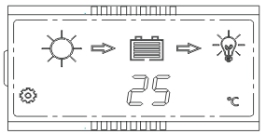When the LCD shows as the left,press the MENU key for 1s,the icon flashes,you can press OK to clear the Bluetooth device password set by the mobile app.

For device passwords,please refer to the Bluetooth APP instructions.

**7.4 Battery type**

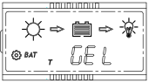When the LCD shows the interface at left ,press the MENU key,the iconflashes,you can set battery type.

|  |  |
| --- | --- |
| Display | Battery type |
|  | GEL |
|  | Liquid |
|  | AGM |
|  | Lithium |

1.Charging Volage Parameters(Liquid,GEL,AGM)

When choosing Liquid,GEL or AGM for battery type,the parameters of boost,equalization and float charge voltage can be set by mobile phone APP.The range of parameters is as follows.

The following voltage parameters are 25℃/12V system parameters,24 /48V system automatically multiplied by 2/4 .

|  |  |  |  |
| --- | --- | --- | --- |
| Charging stage | Boost | Equalization | Float |
| Charging Voltage Range | 14.0~15.0V | 14.0~15.0V | 13.4~14.5V |
| Default Charging Volage | 14.5V | 14.8V | 13.7V |

2.Charging Voltage Parameters(Lithium)

When choosing lithium battery type,the overcharge protection and overcharge recovery voltage of lithium battery can be set by mobile phone APP.

Lithium overcharge protection voltage range: 10.0-32.0V(default 12.6V)

Lithium overcharge recovery voltage range: 9.2-31.8V(default 12.4V)

 **Note:**

(Overcharge Recovery Voltage +1.5V)>=Lithium Overcharge Protection Voltage >=(Overcharge Recovery Voltage+0.2V)

Mobile App does not support parameters beyond this range.



**Warming:**the required accuracy of PVM shall be at least 0.2V.If the deviation is higher than 0.2V,the manufacturer will assume no liability for any system malfunction caused by this.

**7.5 Load mode**

|  |  |
| --- | --- |
| Display | Load mode |
|  | Always on Mode:  The load output is always switched on. |
|  | Dusk to Dawn Mode:The load output is switched on between sunset and sunrise. |
|  | Evening Mode:The load output will be switched on for 2~9 hours after sunset. |
|  | Manual Mode:The load output can be switched on and off manually by pressing **MENU** shortly. |

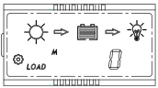When the LCD shows the interface on the left,press the MENU key,the icon flashes,you can set the load mode.

1. **Always on Mode:**

When the controller is set to always On mode,no matter the charging or discharging state,the load always has output(except the protection state).

1. **Dusk to Dawn or Evening mode:**

When the load is set to Dusk to Dawn or Evening mode,the Day/Night threshold voltage and the Day/Night delay time can be set by the mobile phone APP.and the load can be turned on or off by the test function during the day charging process.

**2.1 Day/Night threshold voltage**

The controller recognizes day and night based on the solar array open circuit voltage.

This day/night threshold voltage can be modified according to local light conditions and the solar array used.

Day/Night threshold setting range:3.0~20.0V(lithium,default:8.0V)

Day/Night threshold setting range:3.0~10/6.0~20/12~40V(liquid/Gel/AGM,Default:8/16/32V)

**2.2 Day/Night delay time**

In the evening,when the solar array open circuit voltage reaches the setting day/night detect voltage,you can adjust the day/night delay time to make the load turn on a little later.

Day/Night delay time setting range:0~30 min(default:0 min).

**2.3 Test Function**

When the controller is working in Dusk to Dawn or Evening mode,press the MENU key for 3s to turn on the load .press the MENU key again or the load truns off automatically after 1 minute.

1. **USE Mode**

① If the load mode is selected”USE”,you can switch on and off the load output manually by pressing MENU shortly.

② The default switching state of the load in manual mode can be changed by mobile APP.

At the same time.the output of the load can be turned on or off.



1. If the controller turns off the load due to low voltage protection.over-current protection.short-circuit protection or over temperature protection..the load will turn on automatically when then controller recovery from protection state.
2. Please note:Pushing the MENU button can still activate the function of the key,even during of the above four kinds protection states.

**7.6 Fault indication**

|  |  |  |  |
| --- | --- | --- | --- |
| Faults | Reason | Description | Troubleshooting |
|  | Short circuit | Load off,fault icon display,load icon flashes,the LCD screen displays E1 | Switch off all loads, remove short circuit, load will be  reconnected after 1 minute automatically |
|  | Over current | Load off,fault icon display,load icon flashes,teh LCD screen display E2 | Reduce the load, the controller will resume  to work after 1minute. |
|  | Low battery voltage | Battery lever shows empty,fault icon display,battery frame flashes,the LCD screen displays E3 | Load will be reconnected when battery is recharged |
|  | Over battery voltage | Battery lever shows full,fault icon display,battery frame flashes,the LCD screen displays E4 | Check if other sources overcharge the battery.  If not, controller is damaged. |
|  | Over temperature | Turn off the charge and discharge,fault icon display,icon C flashing,the LCD screen displays E5 | After the temperature decreases,  the controller will work normally |
|  | Communication failure |  | Reconnect after disconnecting the battery for about 1 minute and reconnect the Bluetooth device. |
|  | Battery voltage is abnormal at start-up |  | Charge or discharge the battery so that the battery voltage is within the normal operating range(8.5~15.5V or 20~30V or 40~60V) |
| Battery can’t be charged during daytime | PV panel fault or reverse connection |  | Check panels and connection wires |

**7.7 Protection**

|  |  |
| --- | --- |
| **Protection** | **Description** |
| PV Over Current | The controller will limit charging power in rated charge power.An over-sized PV array will not operate at maximum power point. |
| PV Short Circuit | When PV short circuit occurs,the controller will stop charging.Remove it to start normal operation. |
| PV Reverse Polarity | Fully protection against PV reverse polarity,no damage to the controller.Correct the connection to start normal operation. |
| Battery Reverse Polarity | Fully protection against battery reverse polarity,no damage to the controller.Correct the connection to start normal operation. |
| Battery Over Voltage | If there are other energy sources to charge the battery,when the battery voltage exceeds 15.8/31.3 /62.3V,the controller will stop charging to protect the battery from overcharging damage. |
| Battery Over Discharge | When battery voltage drops to the setting voltage point of Low Votage Disconnect.the controller will stop discharging to protect the battery frm over discharging damage. |
| Load Over Current Protection | If the load current exceeds the maximum load current rating 1.25 times.the controller will disconnect the load. |
| Load Short Circuit Protection | Once the load short circuit happens,the load short circuit protection will start automatically. |
| Over Temperature Protection | The controller detects the internal temperature through internal sensor,when the tepearture exceeds the setting value the charging current will lower down followed by the decrease of temperature rise,when the internal temperature exceeds the setting over temperature protection threshold,the controller stops working and restores afterthe temperature is lowered. |
| Damaged Remote Teamperature Sersor | If the temperature sensor is short-circuited or damaged,the controller will be charging or dicharging at the default temperature 25℃ to prevent the battery damaged from overcharging or overdischarged. |

**7.7 Maintenance**

The following inspections and maintenance tasks are recommended at least two times

per year for best performance.

❶Make sure no block on air-flow around the controller. Clear up any dirt and fragments on radiator.

❷Check all the naked wires to make sure insulation is not damaged. Repair or replace some

wires if necessary.

❸Tighten all the terminals. Inspect for loose, broken, or burnt wire connections.

❹Check and confirm that LCD is consistent with required. Pay attention to any

troubleshooting or error indication .Take corrective action if necessary.

❺Confirm that all the system components are ground connected tightly and correctly.

❻Confirm that all the terminals have no corrosion, insulation damaged, high

temperature or burnt/discolored sign, tighten terminal screws to the suggested torque.

❼Check for dirt, nesting insects and corrosion. If so, clear up in time.

WARNING：Risk of electric shock!

Make sure that all the power is turned off before above operations,

and then follow the corresponding inspections and operations.

1. **Technical Data**

|  |  |  |
| --- | --- | --- |
|  | Type | MT3075-BT |
| Battery Parameters | System Voltage | 12V/24V automatical recognization |
| Max Charging Current | 30A |
| MPPT Charging Voltage | <14.5/29.0V@25℃ |
| Boost Voltage | 14.0~14.8V /28.0~29.0V @25℃(default:14.5/29V) |
| Equalization voltage | 14.0~15.0V/28.0~30.0V @25℃(default:14.8/29.6V) |
| Float Voltage | 13.0~14.5V/26.0~29.0V @25℃(default:13.7/27.4V) |
| Low Volt. Disconnect | 10.8~11.8V/21.6~23.6V,SOC1~5(default:11.2/22.4V) |
| Low voltage reconnect | 11.4~12.8V/22.8~25.6V (default:12.0/24.0V) |
| Overcharge Protect | 15.8/31.3V |
| Max volt on Bat. terminal | 35V |
| Temp. Compensation | -4.17mV/K per cell (Boost, Equal)，  -3.33mV/K per cell (Float) |
| Charging target voltage | 10.0~32.0V ( Lithium,default:12.6V) |
| Charging recovery voltage | 9.2~31.8V (Lithium,default:12.4V) |
| Low voltage disconnect | 9.0~30.0V (Lithium,default:9.0V) |
| Battery Type | Flooded, Gel, AGM=sealed,Lithium (default: Gel) |
| Panel Parameters | Max volt on PV terminal | 55V (-20℃), 50V (25℃) |
| Max input power | 390W(12V system) / 780W(24V system) |
| Day/Night threshold | 3.0~20.0V (default : 8.0/16.0V ) |
| Day/Night delay time | 0~30 min (default: 0 min) |
| MPPT tracking range | （Battery Voltage + 1.0V）~ Voc*0.9 |
| Load | Output Current | 30A |
| Load mode | Always on, Dusk to Dawn, Evening, Manual |
| System Parameters | Grounding | Common Negative |
| Power terminals | #4 AWG |
| Max tracking efficiency | >99.9% |
| Max charge conversion | 98.00% |
| Max tracking efficiency | >99.9% |
| Max charge conversion | 98.00% |
| Dimensions(mm) | 189*182*64 |
| Weight | 1kg |
| Self consumption | <=13mA |
| Ambient temperature | -20 ~ +55℃ |
| Storage temperature | -25 ~ +80℃ |
| Ambient humidity | 0 ~ 100%RH |
| Protection degree | IP32 |
| Max Altitude | 4000m |

*1.This value represents the maximum voltage of the solar panel at the minimum operating ambient temperature.

*2.Voc means the open circuit voltage of the solar panel.

*3.Around oblique line value separately on behalf of 12V and 24V system's value.

1. **Parameter table**

Contact us if you have any question.our email is **[coolper_us@163.com](mailto:coolper_us@163.com)**

If you have any question,you could tell us your parameters in the following format

|  |  |  |
| --- | --- | --- |
| parts |  | parameter |
| Panels | quantity |  |
| Per VOC |  |
| Per power |  |
| Series or Parallel Connection |  |
| Battery | Battery type |  |
| per Voltage |  |
| quantity |  |
| Series or Parallel Connection |  |
| Per capacity |  |
| Inverter | input voltage |  |
| power |  |
| output voltage |  |
| Connection placement |  |
| Load | Which product |  |
| Rated voltage |  |
| power |  |
| AC or DC |  |
| Connection position |  |
| Continuous rainy days |  |
| Working hours everyday |  |
| Problem description |  | |